UML:

-------------------

| InventoryManagementSystem |

-------------------

| - productTable: TableView |

| - productList: ObservableList |

| - initializeProductTable() |

| - deleteProduct() |

| - updateProduct() |

| - insertProduct() |

| - showAlert() |

| - showUpdateWindow() |

| - showInsertWindow() |

-------------------

-------------------

| Product |

-------------------

| - name: String |

| - price: Double |

| - description: String |

| - nameProperty(): StringProperty |

| - priceProperty(): DoubleProperty |

| - descriptionProperty(): StringProperty |

| + deleteProduct(ObservableList<Product>, Product) |

| + updateProduct(Product, String, double, String) |

| + insertProduct(ObservableList<Product>, String, double, String) |

-------------------

Relationships:

* InventoryManagementSystem uses Product class to manage products in the inventory.
* Product class has a bidirectional association with InventoryManagementSystem class, as it's used by InventoryManagementSystem to manage products and InventoryManagementSystem also has a dependency on Product class for managing products.
* Product class contains attributes and methods to represent and manipulate product data.
* Product class also contains static methods for deleting, updating, and inserting products, which are used by InventoryManagementSystem class.
* InventoryManagementSystem also uses JavaFX components like TableView and Stage to create GUI components and manage user interface.

Screenshots:

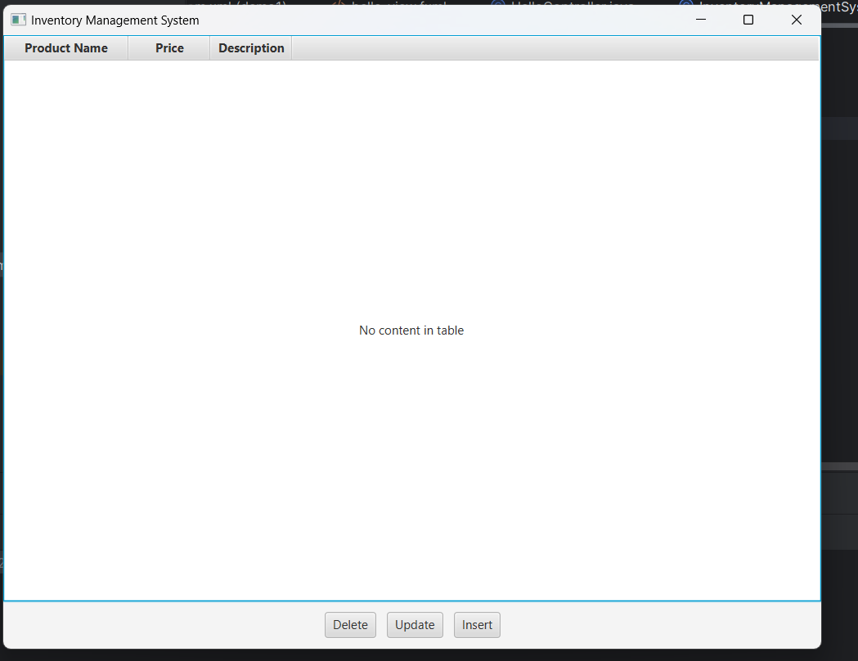

Initial Opening

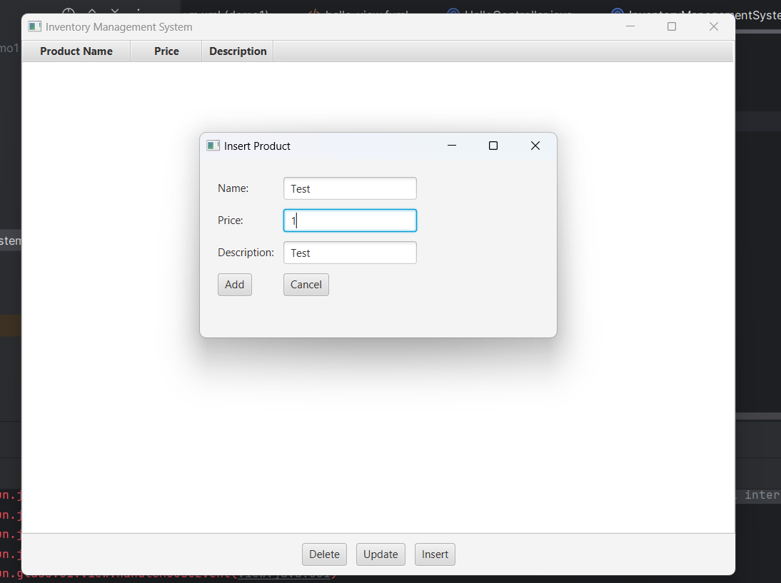

Window opening on clicking the insert button

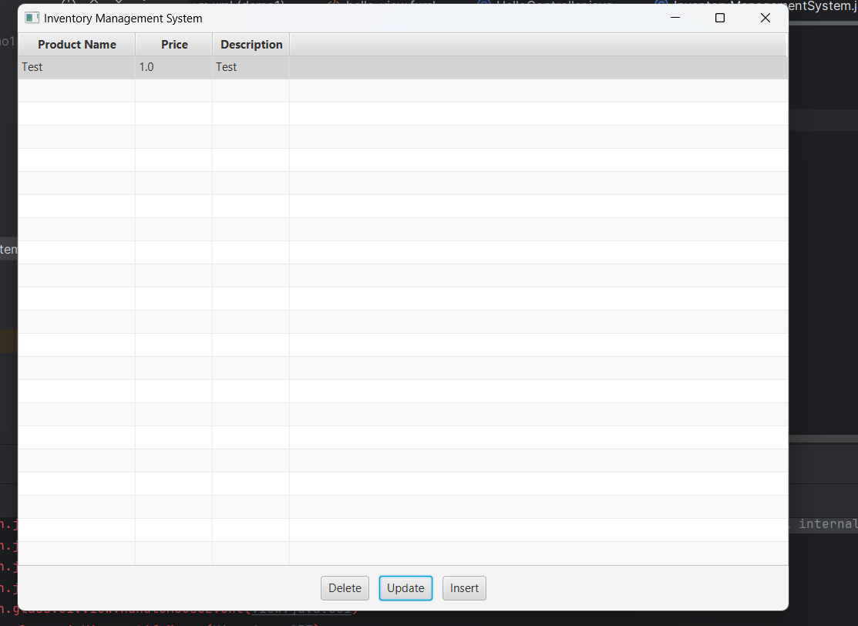

Result of test insert

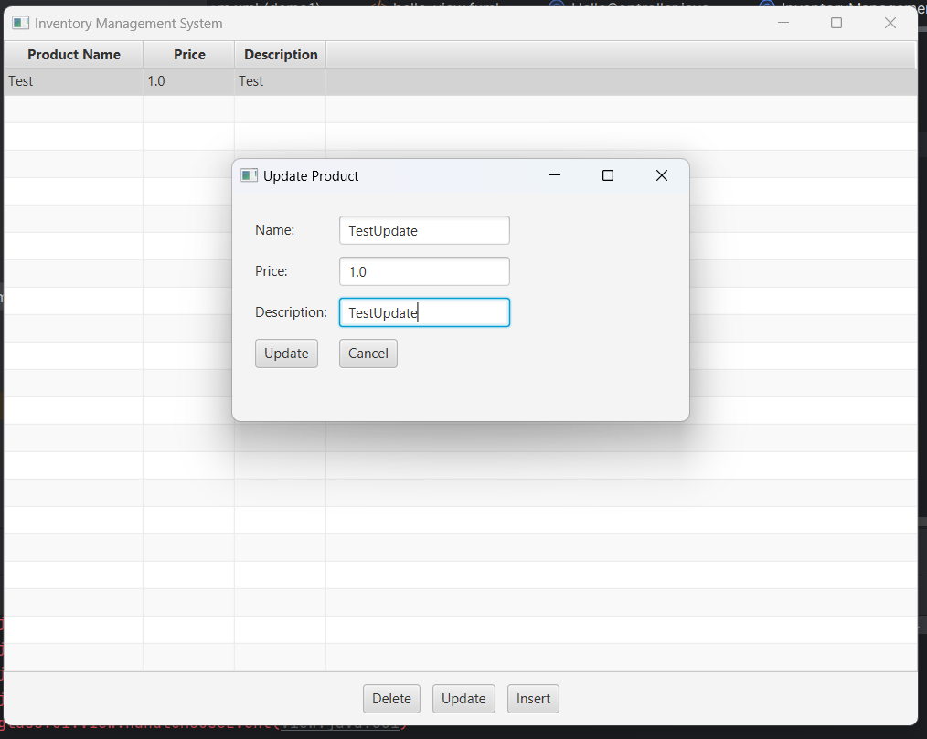

Window that pops up when you click a product and then click the update button.

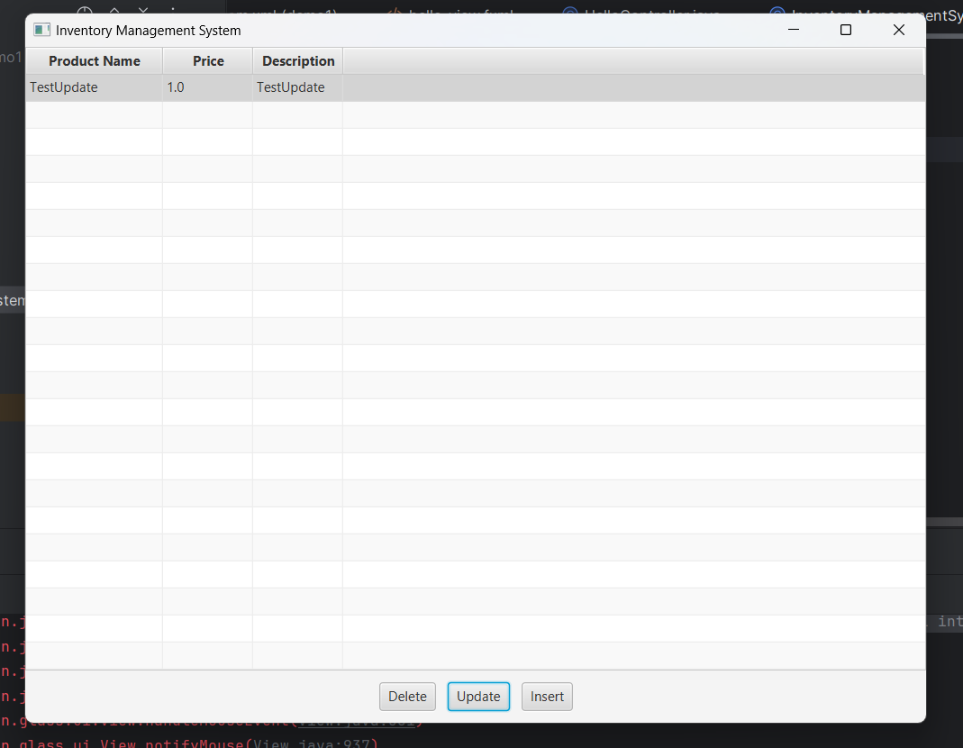

Result of test update



Result of clicking a product and clicking the delete button